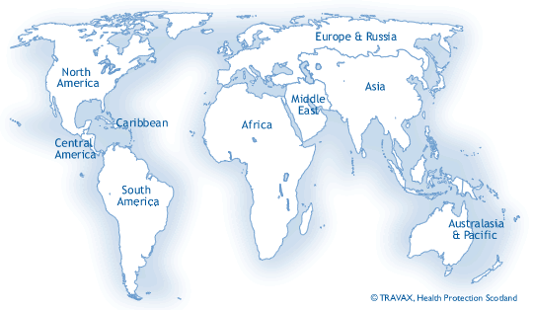
Missionary Volunteer Program
June 2026
Dear Friends,
Our time in Serbia has been flying by and we are so thankful to be here. Highlights of our ministry this month follow:
- Church services were wonderful! With people from up to eight countries represented, every service was a treat. For our Sunday morning service, volunteers would translate the message into Russian, which was the largest group represented. Our song service, led by a Mexican, was in three languages every Sunday morning: English, Serbian, and Russian. Joanie performed two sign-language songs on two Sundays and I sang a special with three other men one Sunday. They loved these specials . Several Sundays the fellowship went on for a while after service ended, and we usually had some snacks available. We had a potluck supper one week and chili one Sunday night.
- Joanie cooked several meals for different families and singles over the five weeks there. Spending extra time with these folks really knit our hearts together. They loved her meals, and many of them were tasting these dishes for the very first time. I was able to meet a couple of men for coffee and fellowship, and we were able to eat out a couple of times with folks from church.
- Outreach was exciting for us. Two Saturdays our group gave free Bibles and other publications to people at the public market. All of the materials had the church QR code on them for folks to follow-up and contact the church with questions, requests, etc. One weekend several of us canvassed homes and apartments in neighborhoods near the church. We gave out Serbian Bibles, John & Romans, and other church material. Again, everything had the church QR code on them. I was able to give out several Bibles and material to different servers/baristas that I met over our time there. One waiter was especially eager to have a Serbian Bible of his own and was so thankful that he wouldn’t charge me for my coffee that morning. Please pray that Marco will be tender to the gospel as he reads the Word of God.
- The weather was very hot most days, so Joanie and I often had umbrellas with us as we walked to and from the nearby grocery stores for a little relief from the intense sunshine.
- Since we lived above the church, we were able to visit and play with the missionary family’s two cats that lived in another room downstairs. They were fun and naughty, too. (They love bread, and they would find ours in the kitchen! Ha!) They missed their “parents” so we did our best to care for them and give them treats…they adored tuna,
- It was very exciting to be part of this international ministry, and they really looked after us and made sure we always had whatever we may have needed. We’ll miss these folks, but, Lord-willing, we will try to visit again in May 2027 so we can spend time with the Missionary family and see everyone at church again. I was asked to speak at a Mission Conference at a thriving work in Milan that same month..
Thank you for your prayers. Although we were warned about a potential conflict between some people at church, there were no conflicts or problems whatsoever while we were there.
We are planning our schedule for 2027, and it looks like we will be very busy in the year ahead. Just yesterday we were asked to fill the pulpit in Croatia next fall for 3 months.
Now, for the next month we will be preparing for our 3-month trip to Tanzania (Beginning mid-August).
For a Greater Harvest,
Darrell and Joanie Bolton
